**Homepage:**

1. Brand Central –
   1. Use the Agency font instead of Calibri in this area
2. Home | Templates | Designer Tabs –
   1. Center these to be in the middle of the page
3. Lockheed Martin Logo –
   1. Add the logo to the right side of the page  
       (parallel to the Brand Central header but on the right side)
4. Header Image –
   1. I would like the header to stretch the full length of the page
   2. Welcome to Brand Central needs to be an overlay (static) with the pictures moving under it.
   3. If this is not possible, I would like to have just a static image with the brand central overlay. You can remove the arrows.
5. Blue Box –
   1. Active Links should be a blue
   2. Inactive links should remain black
6. Body Copy-
   1. Can we format the body copy to not pass the header image?

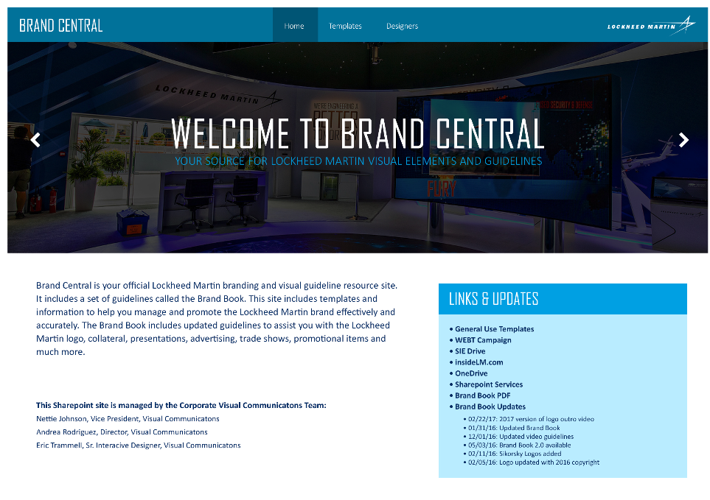

1. Footer –
   1. Remove the information in the footer to just be the specific color.
   2. (Remove site owner, terms, etc.)

**Templates Page + Designer Page**

(Same as homepage)

1. Brand Central –
   1. Use the Agency font instead of Calibri in this area
2. Home | Templates | Designer Tabs –
   1. Center these to be in the middle of the page
3. Lockheed Martin Logo –
   1. Add the logo to the right side of the page  
       (parallel to the Brand Central header but on the right side)
4. Header Image –
   1. I would like the header to stretch the full length of the page
   2. Welcome to Brand Central needs to be an overlay (static) with the pictures moving under it.
   3. If this is not possible, I would like to have just a static image with the brand central overlay. You can remove the arrows.
5. Remove the gap that is between the header image and the *download brand book* section.



1. Change the font of the *download brand book* section to the agency font
2. Footer – (Same as homepage)
   1. Remove the information in the footer to just be the specific color.
   2. (Remove site owner, terms, etc.)